Advanced Graphics Programming (CUP688)
Creating Custom Skybox Cube Maps

Introduction
This tutorial will teach how to create custom cube map .dds textures using DirectX Texture Tool.

Prerequisites
DirectX Texture Tool installed (can be acquired by downloading the legacy DirectX SDK. You will also need some textures to use in the creation of a cube map, you can find some in Resources.zip on SOL.

1. Creating Cube Maps in DirectX Texture Tool
Below is a guide for creating a cube map.

- Open DirectX Texture Tool. This can be done by searching for it in the Windows Start menu.
- Go to File → New Texture.
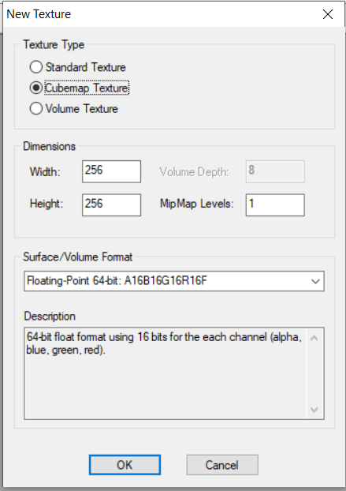
- Create a 256x256 cubemap texture using 64-bit floating point (A16B16G16R16F):

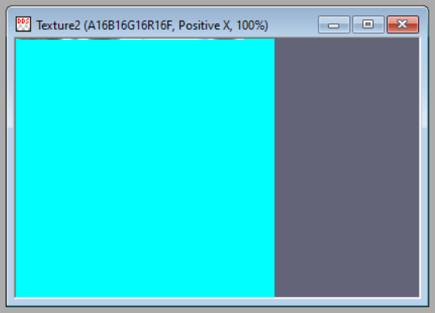
- Make the texture window wider, you will need to see the name of the window to see which side of the cubemap is currently viewed.
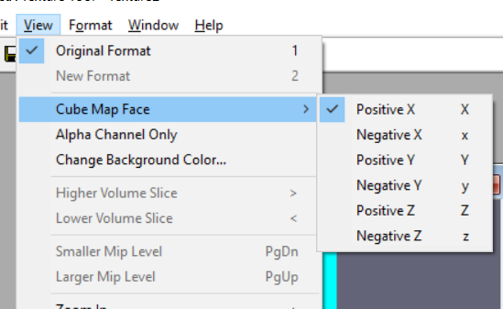
- You can go to the different cubemap faces by going to View → Cube Map Face and selecting the face you want to view. You can also use x, shift+x, y, shift+y, z and shift+z keyboard shortcuts to go to positive and negative X, Y, Z faces.
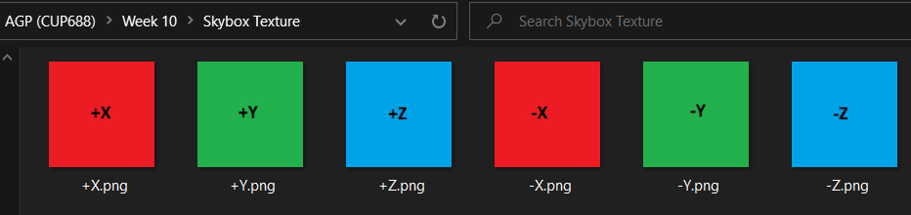
- In Resources.zip, you will find a texture for each side of the cube.

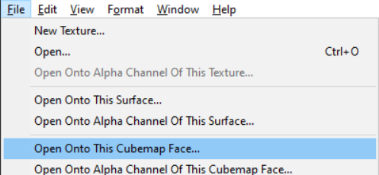
- Go to each face of the cube, and using File → Open Onto This Cubemap Face, load each texture to the appropriate face.
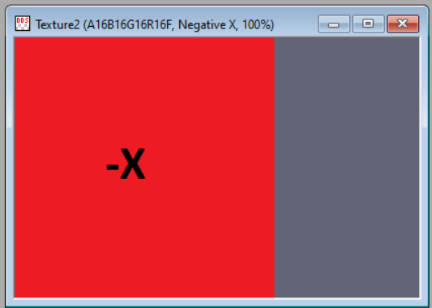
- As an example, the -X texture is loaded onto the negative X face.

- Once all 6 faces have been loaded, go to File → Save As. Give it an appropriate name such as TestCubemap.dds, and save it in your project directory.
- Within your code, change the name of the texture being loaded inside InitGraphics.
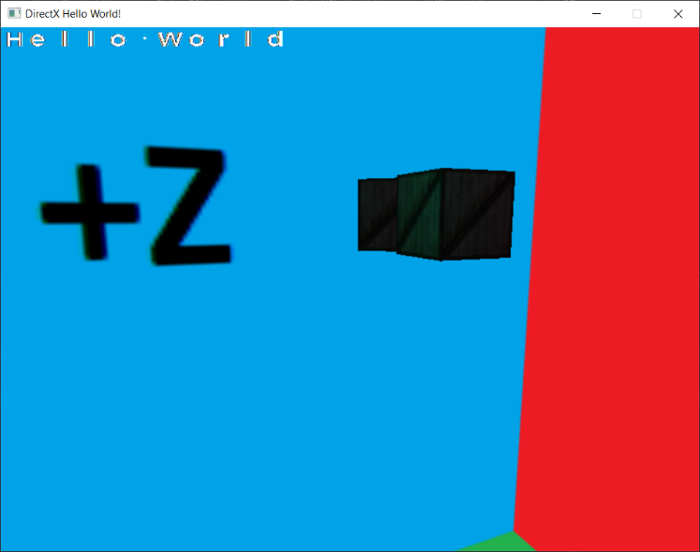
- When you run your project, you should see something like this:
Make sure all 6 faces display the correct side of the texture.

